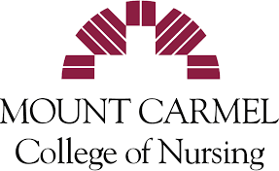

Student Ambassador Application
2021
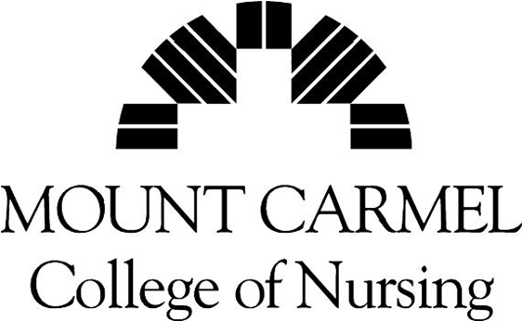
Mount Carmel College of Nursing
Student Ambassador Program Application

PERSONAL DATA

Name: ____________________________________________ Date: ___________________

Cell Phone: ____________________________________________

Address: _______________________________________________________________________

Email: _________________________________________________________________________

Hometown: ________________________________ High School: ________________________

MCCN Entrance Date: ________________________

Semester Hours Completed: _____________Current Cumulative GPA: ______________________

Expected Year and Semester of Graduation: ____________________________________________

Current Enrollment Status (FR, SOPH, JR): ________________________________________

Current Community Involvement: _______________________________________________________________________________

_______________________________________________________________________________

What languages other than English do you speak fluently? ________________________________

List activities, participation, honors/awards you have received and leadership activities/programs throughout your high school and/or college experience: ________________________________________________________________________________________

________________________________________________________________________________________

________________________________________________________________________________________

Hobbies/Interests: ____________________________________________________________________________________________________________________________________________________________________________________
Additional Information you want the selection committee to know: ____________________________________________________________________________________________________________________________________________________________________________________

EMPLOYMENT HISTORY AND REFERENCES
(Please list your last three places of employment)

Place of Employment & Job Title: __________________________________________________________
Dates of Employment: ____________________________________________________________________
Job Description: _________________________________________________________________________

Place of Employment & Job Title: ___________________________________________________________
Dates of Employment: ____________________________________________________________________
Job Description: __________________________________________________________________________

Place of Employment & Job Title: ___________________________________________________________
Dates of Employment: _____________________________________________________________________
Job Description: __________________________________________________________________________

Are you currently working? Yes __________ No ___________

If yes, place of work: ___________________________________________________________

Job Title: _____________________________________________________________________

Please list three references (at least one MCCN faculty or staff member preferred if available). In addition, please include at least one former high school counselor or teacher if you have attended a local high school within the last three years.

Name Job Title Phone#

1.______________________________________________________________________________________

2.______________________________________________________________________________________

3.______________________________________________________________________________________

Consent for Verification of Student Records:
I hearby certify that all statements made on this application are true and correct to the best of my knowledge and authorize investigation of all statements herin recorded. I release from all liability persons and organizations reporting information required by this application. I grant permission to an authorized representative of Mount Carmel College of Nursing to verify my student records for purposes of this application. I understand that in order to be considered for a position as a College Ambassador, I must be in good academic standing.

Signature: __________________________________________________Date: ____________________

Mount Carmel College of Nursing is committed to providing equal education and employment opportunities to all persons regardless of, but not limited to, race, color, religion, national origin, gender, marital or parental status, disability, age, sexual orientation, or status.

On a separate sheet of paper, briefly type answers to the following questions:

- Please describe, in detail, why you would like to serve as a Mount Carmel College of Nursing Student Ambassador. Include any qualities/qualifications that you feel would qualify you to be selected as a Student Ambassador.

- If you were selected to serve as a Student Ambassador, how do you feel your role on campus would change?

- What specific skills and knowledge do you hope to gain from your participation in Mount Carmel College of Nursing’s Student Ambassador Program?

- Think back to when you chose to attend Mount Carmel College of Nursing. Please describe the most positive/exciting characteristics about Mount Carmel College of Nursing and how you would share them with potential MCCN students.

*Please return the completed application form along with a copy of your class schedule and answers to questions to Kim M. Campbell, PhD.

- Mail, email, fax
- If Lancaster Campus, you may also give to Cora Arledge to bring to main campus
- Fax: 614 - 234 - 5427
- Email: kcampbell@mccn.edu

Applications without the appropriate signatures cannot be accepted. If you have any questions please contact Kim M Campbell at kcampbell@mccn.edu via email or at 614-234-5144. Thank you.

